

2018



HewleySonaram (1027662)

Nicardo Wharton (1022583)

Kevon Hodge (1026779)

Govindanath Persaud (1028039)

Devonte Richards (1024599)

University of Guyana

10/23/2018

Database Management System

CSE2102

Assignment

3

* 1. **TABLE OF CONTENTS**

**GENERAL INFORMATION**

* 1. **Purpose**

The purpose of this DBMS (Database Management System) is to solve the problem where by teachers are not adequately assigned to rooms, they are unable to currently know who is utilizing the faculty/teaching rooms at given times.

## Objective

The objective of this DBMS (Database Management System) is to have a easier way of locating, assigning, and querying the times, dates/days when the classrooms will be occupied.

## Scope

The scope of this DBMS (Database Management System) is specifically for the University, we will be handling the Rooms assignment of rooms (times and dates) for Tutorial Lecturers and Course lecturers.

## System Overview

The University does not have a DBMS (Database Management System) for the assessment of classrooms. The implementation of a DBMS will give staff who has permission to access the DBMS to view classroom schedules.

The DBMS will be on a file server which that is stored in a secured air condition room with an adequate UPS (Uninterrupted Power Supply) which will need to be monitored by a computer technician.

## Acronyms and Abbreviations

|  |  |
| --- | --- |
| DBMS | Database Management System |
| UPS | Uninterrupted Power Supply |

* 1. **Points of Contact**

|  |  |  |  |
| --- | --- | --- | --- |
| Name | Department | Telephone # | Email Address |
| John Betters | Faculty Natural  Science | 450-2054 | [John.betters@uosm.stm](mailto:John.betters@uosm.stm) |
| Peter Knox | Faculty of Business | 452-6039 | [Peter.knox@uosm.stm](mailto:Peter.knox@uosm.stm) |

* 1. **Data Owners**

|  |  |
| --- | --- |
| Department | Details |
| Faculty Natural  Science | In charged for providing information for required classes. |
| Faculty of Business | In charged for providing information for required classes. |

* 1. **DATABASE IDENTIFICATION AND DESCRIPTION**
  2. **Naming Conventions**
* Faculty Table Department Courses Lecture
* Rooms Table Rooms Number Projector

Air Conditioner Seating Amount

## Database Identification

This database is made of two tables.

## Systems Using the Database

Faculty System: This system is used by staff to display course times. Rooms System: This system is used by staff to display rooms times.

## 2.0 Physical Design

**DBMS**

**FNS**

**Computer**

**Rooms Computer**

* 1. **DATABASE ADMINISTRATIVE INFORMATION**
  2. **Responsibility**

Identify the organizations and personnel responsible for the following database administrative functions and skill requirements.

|  |  |  |
| --- | --- | --- |
| **Function** | **Personnel** | **Skills** |
| Database Administrator | Internal Administrator | Ability to update and repair the database |
| System Administrator | Internal Administrator | Ability to keep the  database in working order |
| Security Administrator | Internal Administrator | Ability to notice security breaches |

## Hardware Configuration

|  |  |
| --- | --- |
| Processor | AMD EPYC x86 |
| Memory | 16GB |
| Storage | 1TB |

* 1. **Error Handling**

All will be handled by the database administrator if not resolved by the DBMS.

**The Conceptual Database Design**

**Entities**:

Faculty

Room

Schedule

**Attributes:**

**Faculty**-Faculty ID, Name, telephone, Department

**Room** – Room Number, No. of Seats, Room Description

**Schedule**– SID, Time, Course, Day

**Relationship:**

**~**Faculty**Contains**Rooms–Floor, FID, Room Number

~Room **has** Schedule – Room Number , Time

**The Logical Database Design**

**Faculty :**

FacultyID – INT (2)

Name – Varchar (30)

Telephone – Varchar (15)

Department- Varchar (45)

**Rooms:**

Room Number– Varchar (4)

No. of Seats – INT (3)

Room Description – TEXT

**Schedule:**

Course – Varchar (30)

SID – Varchar (5)

Time – TIME

Day – Varchar(10)

**Relationship:**

**~**Faculty **has** Rooms – Floor INT (2), FID INT (2), Room Number Varchar (4)

~Room **has** Schedule – Room Number Varchar (4) , TimeTIME

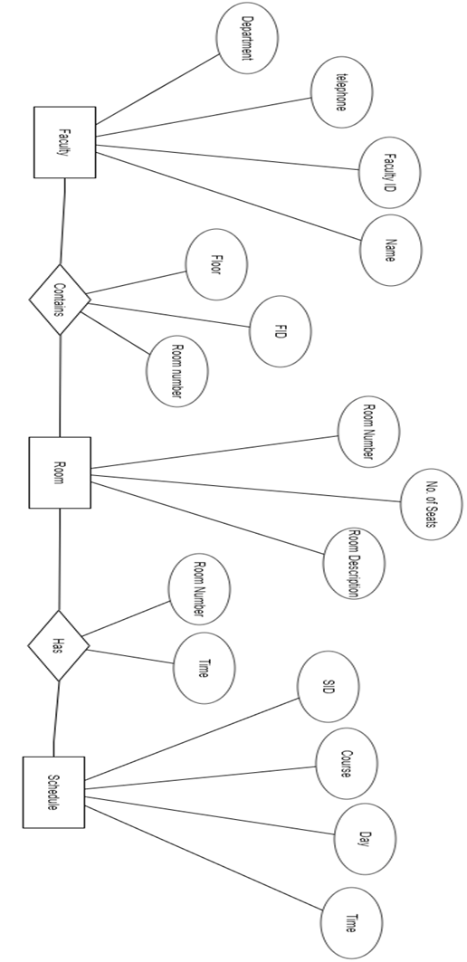

**Entity Relation Diagram**

**Duties of Members**

Hewley Sonaram (GitHub: Hewley) – **Database Administrator**. He will overlook the design of our database, train staff, set up and test the new database, monitor the efficiency of the database, design and prepare reports for management, develop protocols for data processing and create queries. He will be involved in every aspect of this project.

Kevon Deltas (GitHub: KevonHodge) - **Database Designer**. He is responsible for the detailed database design which includes; tables, indexes, views, constraints, triggers, stored procedures, and other database-specific constructs needed to store, retrieve, and delete persistent objects.

### Govindanath Persaud (GitHub: xcodydoe) – **Jr. Database Administrator.** Responsible for installing, maintaining, and supporting all aspects of the relational database management systems that support the company's business applications. Will also maintain the integrity of the data by maintaining proper backup and recovery procedures.

Devonte Richards – (GitHub: Maxxor7) - **Customer Support Engineer –** Will solve customers’ issues and report bugs to developers. He will also inform users of the software’s capabilities. Basically, helps users in solving problems concerning this database management system.

Nicardo Wharton (GitHub: Nicwton) – **Computer Technician –** Will handle all fixing and troubleshooting of hardware/software problems encountered during and after the implementation of this project.